Experiment 10th:

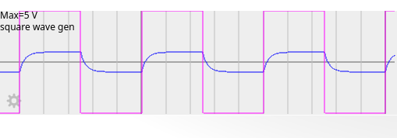

channel 1’s output:

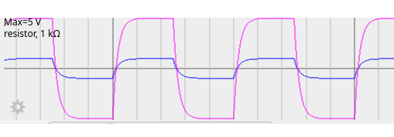

channel 2’s output:

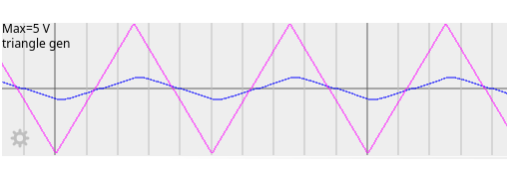

channel 1’s output:

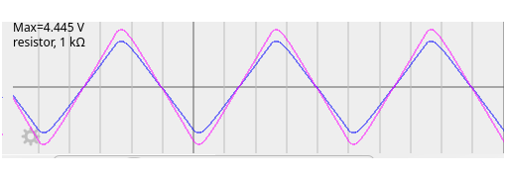
channel 2’s output:

the relationship between input voltage (the voltage of of function gen) and output voltage (voltage of inductor) is :

according to the relationship we can state that:

